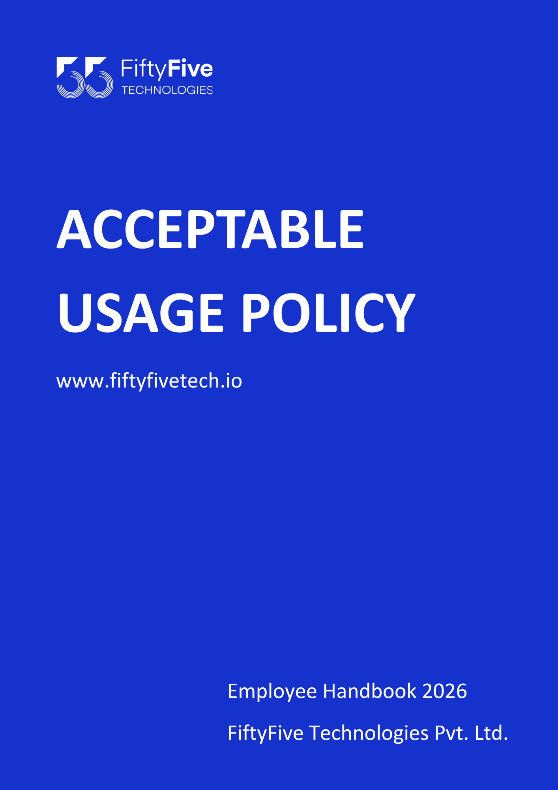

Acceptable Usage Policy

Document Release Notice

This FiftyFive Technologies Policy on acceptable usage policy is released for use in FiftyFive Technologies Pvt Limited with effect from 01 January 2026.

This document is subject to FiftyFive Technologies Pvt Limited Procedure and subject to change at any time as per the company policy.

Approved By: Jyothi Sharma (CEO-FiftyFive Technologies Pvt. Limited)
Approved By: Sanchi Saxena (Head HR-FiftyFive Technologies Pvt Limited)

1. Purpose
The purpose of this Acceptable Usage Policy (AUP) is to define the acceptable use of FiftyFive Technologies's information systems, including but not limited to computers, networks, email, internet access, and any related resources. This policy aims to protect the integrity, confidentiality, and availability of these systems.

2. Scope
This policy applies to all employees, contractors, consultants, temporary workers, and other individuals at FiftyFive Technologies who have access to or use the company’s information systems.

3. General Use and Ownership
- FiftyFive Technologies provides various technology resources to employees for business use. These resources include, but are not limited to, computers, mobile devices, software, email, and internet access.
- All data created on FiftyFive Technologies systems is the property of FiftyFive Technologies. Employees should have no expectation of privacy when using company resources.
- FiftyFive Technologies reserves the right to monitor, inspect, and review all files, emails, and internet use to ensure compliance with this policy.

4. Acceptable Use
Employees, contractors, and any individuals with access to FiftyFive Technologies's information systems are expected to use these resources in a manner that supports the business objectives of the organization. The following outlines acceptable use:
4.1 Business Purposes
- Use FiftyFive Technologies's resources, including email, internet, software, and hardware, to perform your job responsibilities and tasks effectively.
- Access only the information and systems that are necessary for your role and responsibilities.
- Ensure all communications and data transmissions are conducted in a professional manner that aligns with the company’s values and ethical standards.

4.2 Data Protection and Confidentiality
- Handle all company data, including customer information, intellectual property, and internal communications, with the utmost care and confidentiality.
- Ensure that sensitive data is only accessed, shared, or stored in accordance with FiftyFive Technologies's data protection policies and applicable regulations.
- Report any accidental or unauthorized disclosure of sensitive information to the appropriate department immediately.
4.3 Resource Utilization
- Use resources efficiently, including bandwidth, storage, and processing power. Avoid actions that unnecessarily consume excessive system resources.
- Conserve energy by turning off or hibernating systems and devices when not in use, particularly overnight or during long periods of inactivity.
4.4 Compliance with Legal and Regulatory Requirements
- Ensure that your use of FiftyFive Technologies resources complies with all applicable laws, regulations, and contractual obligations.
- Familiarize yourself with relevant legal standards, such as copyright laws, data protection regulations (e.g., GDPR), and industry-specific requirements (e.g., HIPAA for healthcare).
4.5 Training and Awareness
- Participate in any mandatory training sessions related to the acceptable use of technology, information security, or data protection.
- Stay informed about company policies and industry best practices to ensure ongoing compliance and security.
4.6 Remote Work and Mobile Device Use
- When working remotely, ensure that all company resources are accessed through secure, company-approved methods, such as VPNs or other encryption technologies.
- Use mobile devices, including smartphones and tablets, in accordance with the company’s mobile device management policy, ensuring that they are secured and regularly updated.
4.7 Collaboration Tools
- Utilize company-approved collaboration tools, such as video conferencing, instant messaging, and project management platforms, for work-related communication and collaboration.
- Ensure that all usage of collaboration tools adheres to company standards for professionalism, security, and confidentiality.

5. Unacceptable Use
Unacceptable use of FiftyFive Technologies resources includes, but is not limited to:
- Accessing, downloading, or distributing obscene, offensive, or illegal material.
- Engaging in activities that could damage, disrupt, or compromise the company’s systems or network security.
- Using company resources for personal financial gain or political activities.
- Sharing confidential or proprietary information without proper authorization.
- Installing unauthorized software or hardware on company systems.
- Engaging in activities that could result in a conflict of interest with FiftyFive Technologies.

6. Email and Communication Activities
- Use company email primarily for business-related communications.
- Do not use company email to send spam, chain letters, or unsolicited commercial communications.
- Be cautious when opening email attachments or links from unknown sources to avoid phishing or malware attacks.
- Ensure that all communications are respectful and do not harass, discriminate, or defame others.

7. Internet Usage
- Internet access provided by FiftyFive Technologies should be used primarily for business purposes.
- Do not visit websites that are known for containing inappropriate or illegal content.
- Avoid streaming media for non-work-related purposes, as it can consume significant bandwidth.

8. Social Media
- Employees must not post confidential or proprietary information about FiftyFive Technologies, its clients, or partners on social media.
- Personal opinions expressed on social media should not be represented as those of FiftyFive Technologies.
- Employees must adhere to the company’s social media policy [if available] when using social media.

9. Security and Passwords
- Employees are responsible for maintaining the security of their account passwords and must not share them with others.
- Use strong passwords that comply with the company’s password policy.
- Report any suspicious activity or potential security breaches to the IT department immediately.

10. Consequences of Violations
Violations of this policy may result in disciplinary action, up to and including termination of employment. In some cases, legal action may also be taken.

11. Policy Review
This policy will be reviewed annually and updated as necessary to ensure its continued effectiveness and relevance.



